**Exam 1: Problem Solving** (15 points)

**Instructions:**

1. This is an **individual** exam.
2. This is the second part of the two part exam. First part is the multiple choice portion available separately.
3. Provide your responses on this file, save it, and upload the file to the appropriate assignment response in blackboard.
4. You may upload **only one** attempt.
5. Do not handwrite any responses.
6. If you have any additional information you would like me to know about this assignment, you may provide that to me at the end of this document as a note.

Question 1: You are a database designer. You give your manager the following fragment of an ER diagram. Your manager asks you about boxes and funny lines between the two boxes. Explain what those boxes and lines are and what they mean. Remember to explain everything in the diagram, i.e., what are the entities and what type of relationship they are in, and assumptions (if any) that you are making. (5 points)

Manager

Employee

Answer:

The boxes are defined as an entity which can be a noun. Within these entities, they can hold certain attributes that help characterize it. The line in between both entities signifies that there is a relationship among the two. At the end of each line there are certain symbols that are foot notations or known as crow’s foot. One the left side by manager, there is a “0 or 1” which means that the minimum or maximum an employee could have. Essentially, this is telling us that the employee could have one manager or no manager at all because the “0” makes the situation be considered optional. On the right side of the link there is a “one or many” which can represent the amount that was requested or required telling us that there can be either one employee or many employees based on the business requirements or needs. The type of relationship that they have is that the manager (assuming that there is one), is solely responsible for managing the employees. The manager is also optional to the employee(s) as well. An assumption can be made that those who want to sign up for the management position can regardless if there are employees because the manager has a optional relationship to employees. Also, an employee can either be assigned to a single manager or no manager at all.

Question 2: Using the diagram in Question 1 as your starting point, draw an ER diagram (including primary keys and attributes) in which the manager supervises both full time and part time employees. For all employees you want to track their employee type (“Full-time” or “Part-time”), SSN, name, address, and phone number. For full time employees you want to track their salary, benefits and 401k matching %. For part time employees you want to track their hourly rate, hours worked per week, and benefits. An employee can only be a part or full time employee. Benefits of a full-time employee are different from the benefits of a part-time employee. *List any assumptions you have made* (10 points).

Answer: 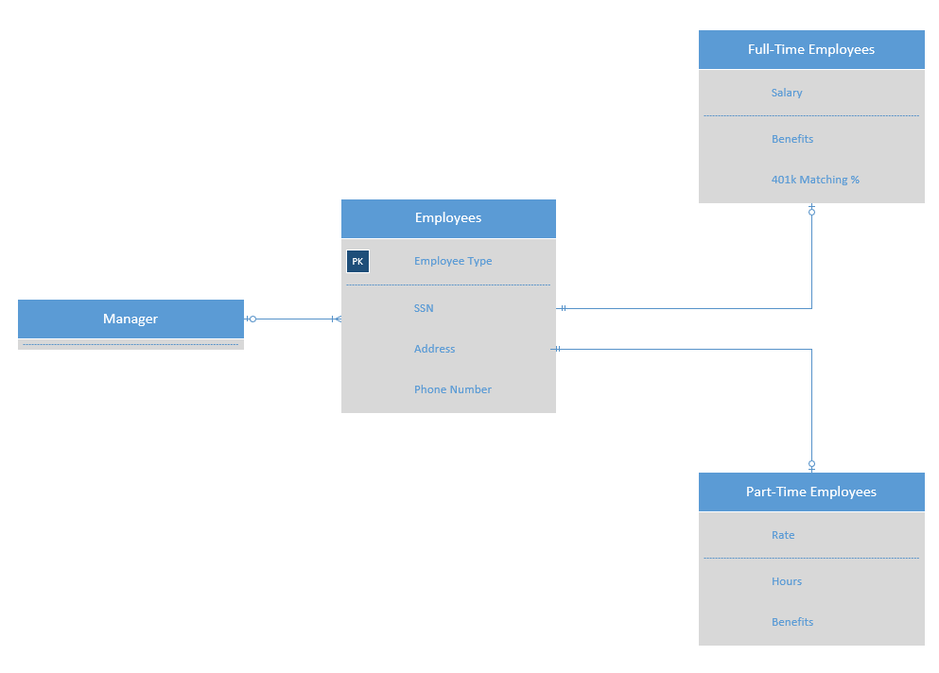

The manager has a “0 or 1” which means it is optional to either have an employee to be managed or just to be a manager. Then the relationship to the employee follows with the “one to many” relationship as there can be either one employee or many depending on the company. And then the employee entity has a primary key of the employee type being either Full-time employees or part-time employees. The attributes for employees in general are the Social security number, Address and Phone number. Then for Full-time employees, there is a “1 and only 1” relationship from the first employee entity because you can’t be a full-time and part time employee at the same time. Then the relationship at the full-time employee is a “0 or 1” which means that there could be a full-time employee, or they are not a full-time employee. The attributes for the full-time employees entity is a salary, benefits, and a 401k matching percent. For the part-time employees the relationship between the first employee entity and part-time is that there is a “1 and only 1” relationship because there can only be a part-time employee or a full-time not both at the same time. The relationship closer to the part-time employee entity is the “0 to 1” relationship which means that there could potentially be a part-time employee or there could not be one. The attributes for a part-time employee were the rate, the hours, and the benefits.